Updated 2026-02-20
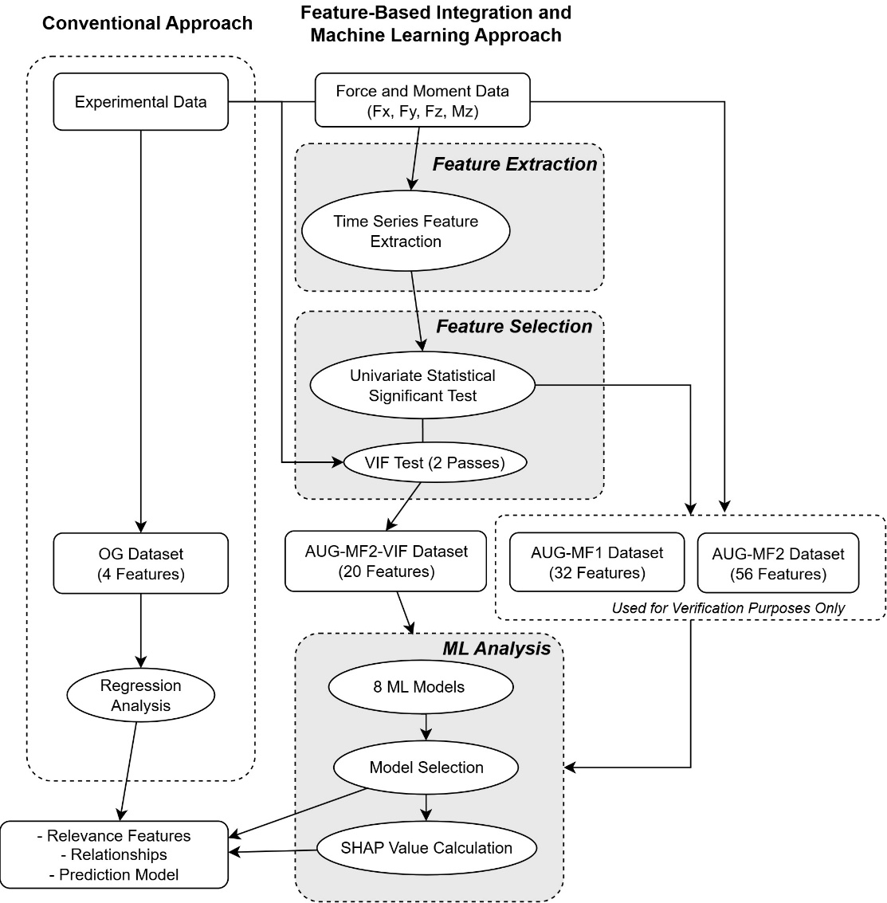
This study compares a conventional experimental data analysis workflow with a proposed feature-based integration and machine learning approach. In the conventional methodology, only the control variables—welding parameters $W$, $D$, $R$, and the measurement position—are used as predictors. These variables form the OG dataset, which consists of four input features and three residual stress responses. Standard regression analysis is then applied to this dataset to evaluate feature significance, estimate regression coefficients that describe the trends, and construct prediction models for the stress values.
In the proposed Feature-Based Integration and ML Analysis Approach, non-tabular experimental data are incorporated by transforming time-series measurements of forces and moment ($F_{x}$, $F_{y}$, $F_{z}$, and $M_{z}$) into engineered features. First, feature extraction is performed: window-averaged values at the stress measurement locations are computed from the time series, and additional time-series descriptors are extracted using the TS-Fresh library. The time series are partitioned into dwell and weld regions so that the importance of features in each region can be investigated separately. Second, feature selection is carried out to handle the large number of extracted features. Univariate statistical significance tests are performed against each of the three stress responses, and features are ranked by their p-values; for each response, the top $M_{F}$features are retained. To further reduce redundancy, variance inflation factor (VIF) analysis is applied in two stages: a first pass is conducted on the time-series-derived features alone, followed by a second pass on the remaining time-series features combined with the original control variables. The resulting VIF-filtered dataset, referred to as the AUG-MF2-VIF dataset with $M_{F}=2$, contains 20 features. Because VIF filtering can sometimes reduce predictive performance, two additional augmented datasets without VIF are constructed for verification: AUG-MF1 (with $M_{F}=1$, 32 features) and AUG-MF2 (with $M_{F}=2$, 56 features).
All datasets (OG, AUG-MF1, AUG-MF2, and AUG-MF2-VIF) are then subjected to a common machine learning pipeline. Eight models are trained: an ElasticNet linear regression model, a support vector regressor with a nonlinear kernel, a k-nearest neighbors regressor, tree-based models including decision tree regressor, random forest regressor, gradient boosting regressor, and XGBoost, as well as a transformer-based tabular model (TabPFN). Model development is implemented using the scikit-learn, XGBoost, and TabPFN libraries, with Optuna employed for hyperparameter optimization. Model selection is based on the coefficient of determination ($R^{2}$), and the best-performing models are subsequently analyzed using SHAP values to quantify feature relevance and to interpret how individual features contribute to the predicted residual stress responses.

Predictor | Coefficient (β) | Std. Error | t-value | p-value | 95% Confidence Interval | Significance
Constant | 0.000 | 0.044 | –0.00 | 1.000 | [–0.086, 0.086] | —
Position | –0.496 | 0.044 | –11.37 | <0.001 | [–0.582, –0.411] | ***
R | –0.174 | 0.044 | –3.98 | <0.001 | [–0.259, –0.088] | ***
W | 0.101 | 0.044 | 2.32 | 0.021 | [0.015, 0.187] | *
D | 0.053 | 0.044 | 1.22 | 0.222 | [–0.032, 0.139] | n.s.

